Name - Shubham Rajendra Gorade
PRN - 260840320163

Q1 :
import java.util.*;
public class QueueDemo {
int stack1[] = new int[10];
int stack2[] = new int[10];
int top1=-1;
int front1=-1;
int top2=-1;
int sizeq;

public void enqueue(int a) {
if(top1==stack1.length-1) {
System.out.println("Queue Overflow");
return;
}

if(front1==-1) {
front1 = 0;
}
top1++;
stack1[top1]=a;
sizeq++;
}

public void dequeue() {
if(top1==-1) {
System.out.println("EMPTY");
return;
}

int temp = stack1[front1];
front1++;
sizeq--;

top2++;
stack2[top2]=temp;
System.out.println(stack2[top2]);
top2--;
}

public void peek() {
if(top1==-1) {
System.out.println("EMPTY");
return;
}
System.out.println(stack1[front1]);

}

public void size() {
System.out.println(sizeq);
}

public static void main(String[] args) {
Scanner sc = new Scanner(System.in);
String choice;

QueueDemo q = new QueueDemo();

do {
System.out.println("We are implementing queue");
System.out.println("E : enqeue");
System.out.println("D : dequeue");
System.out.println("P : peek front value");
System.out.println("S : size");
System.out.println("X : exit");

System.out.println("Enter your choice");
choice = sc.next();
sc.nextLine();

switch(choice) {
case "E" : {
System.out.println("Enter element to be added");
int a = sc.nextInt();
q.enqueue(a);
break;
}

case "D" : {
q.dequeue();
break;
}

case "P" : {
q.peek();
break;
}

case "S" : {
q.size();
break;
}

case "X" : {
System.out.println("Exiting the program");
break;
}

default : {
System.out.println("Enter correct choice");
break;
}

}

}while(choice!="X");

}

}

Output :

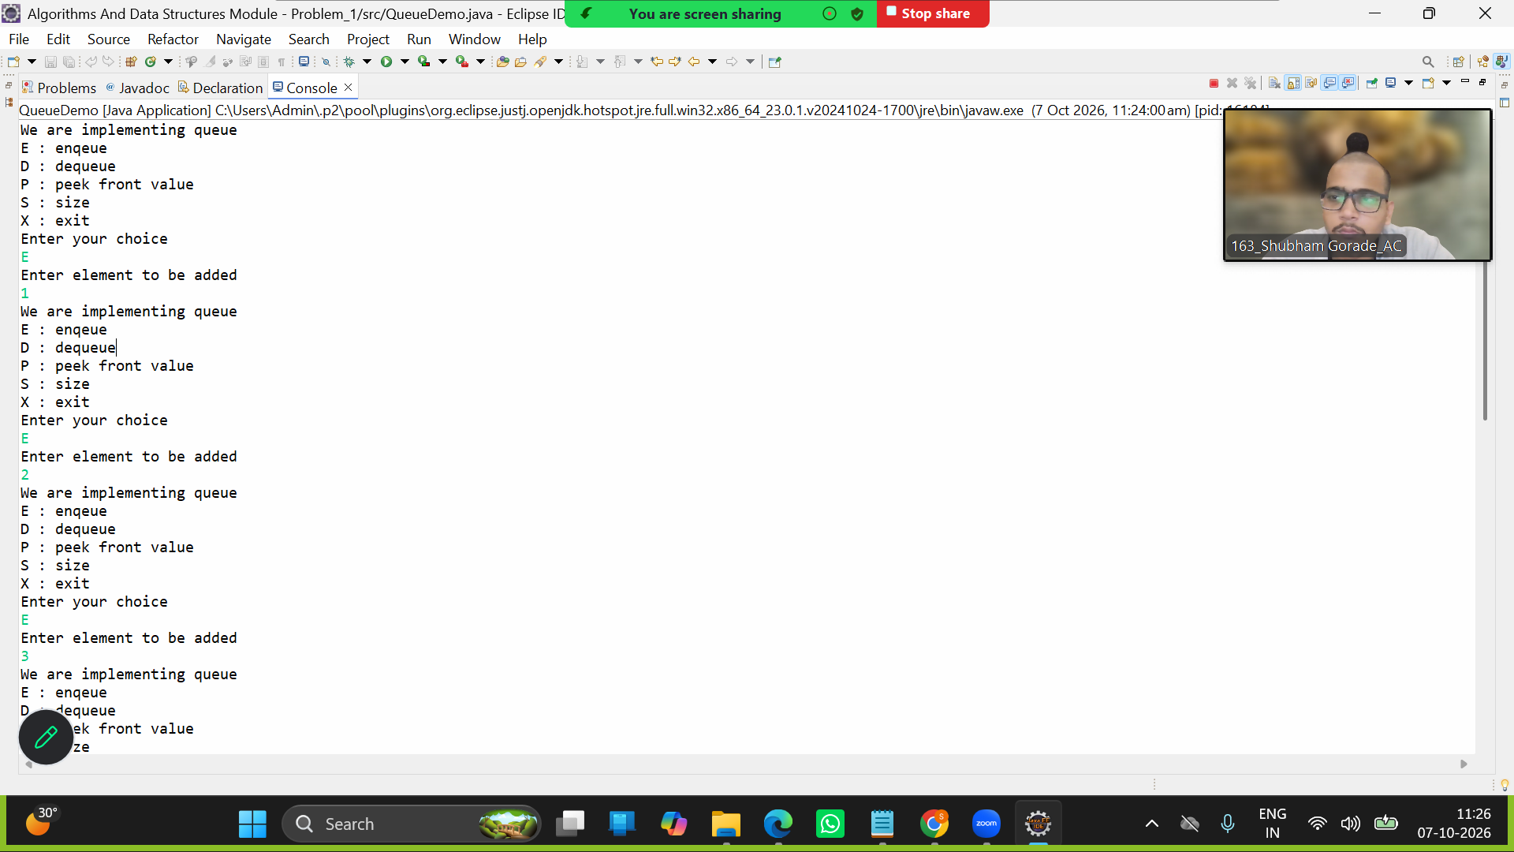

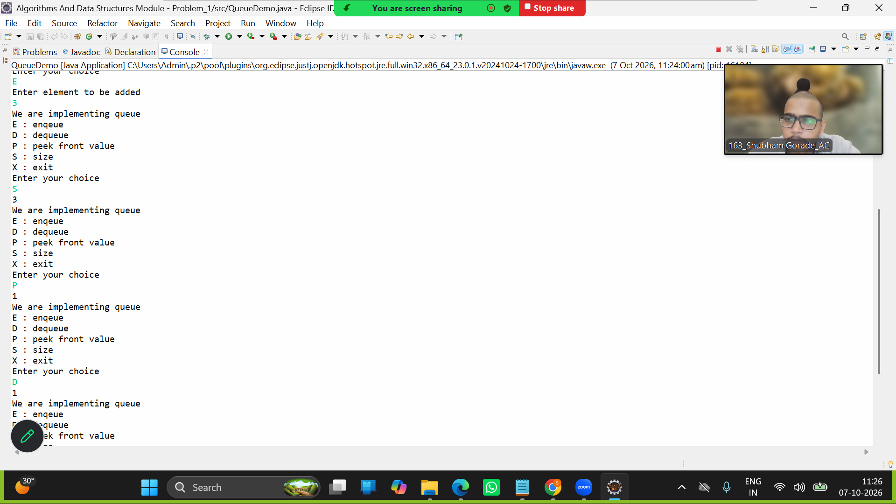

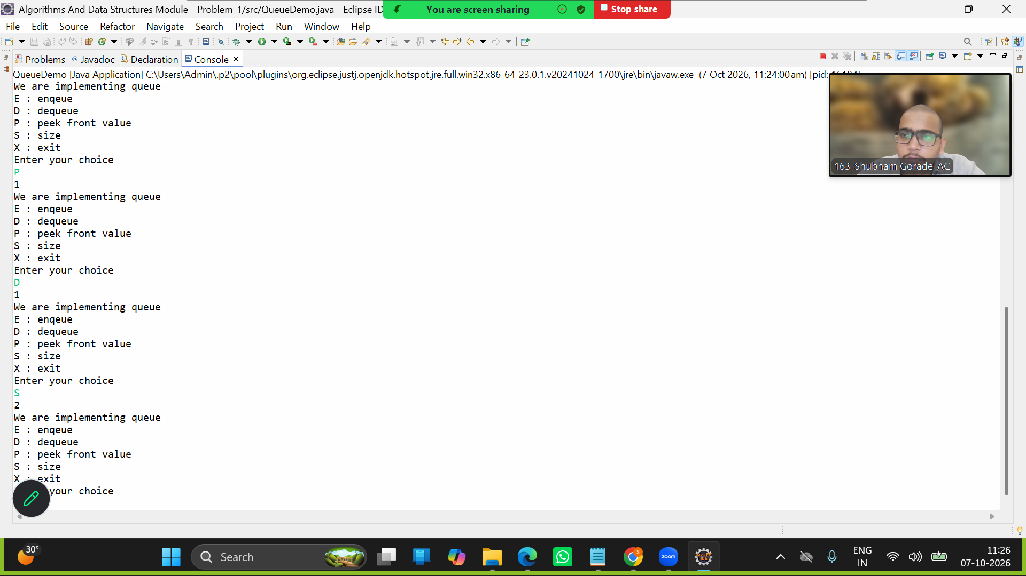

Q2 :
import java.util.*;
public class LinkedListDuplicates {
class Node {
int data;
Node next;

Node(int data) {
this.data = data;
}
}

Node head;

public void add(int d) {
Node n1 = new Node(d);
if(head==null) {
head = n1;
System.out.println("Added in list"+d);
return;

}

n1.next = head;
head = n1;
System.out.println("Added in list"+d);
}

public void printDuplicates() {
System.out.println("Execute");
Node temp1 = head;
Node temp2 = head.next;
for(int i=0; temp1.next!=null; i++) {
int count = 0;
for(int j=0; temp2.next!=null; j++) {
if(temp1.data==temp2.data) {
count++;
}
temp2=temp2.next;
}
if(count==0) {
System.out.println("No Dublicates");
}
else {
System.out.println("Dublicates"+ temp1.data +" "+ count +" "+"times");
}
temp1=temp1.next;

}

}
public static void main(String args[]) {

LinkedListDuplicates l = new LinkedListDuplicates();
l.add(1);
l.add(2);
l.add(3);
l.add(4);
l.add(5);

l.printDuplicates();
}
}

Output :

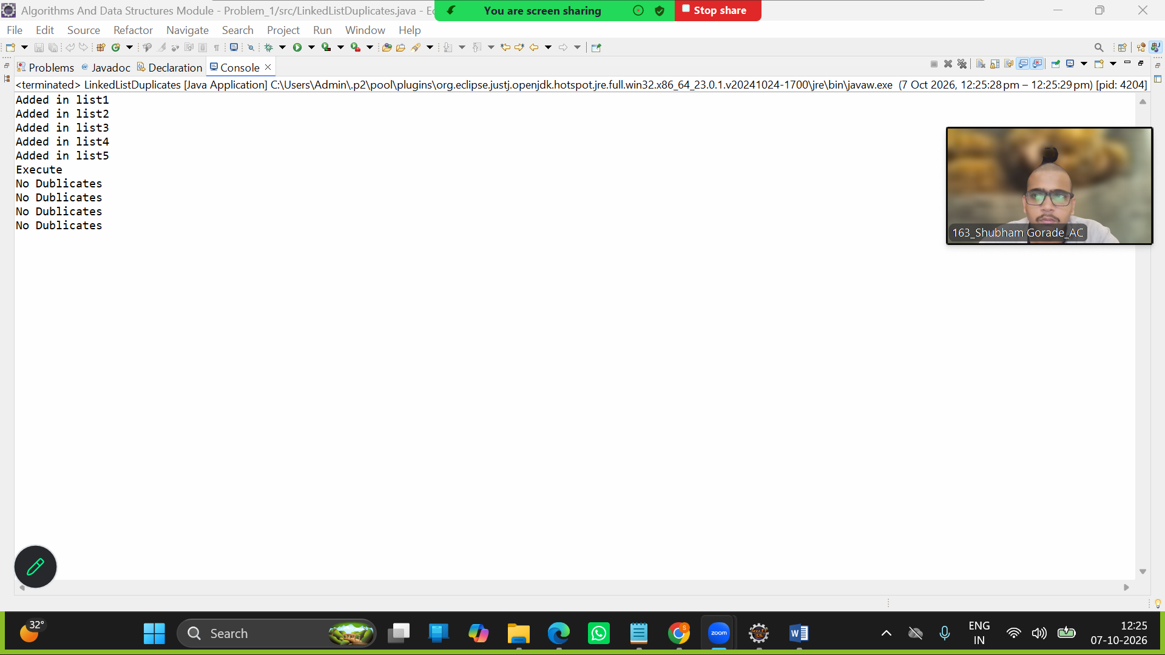
Q3:
import java.util.*;
public class BSTInorder {
class Node {
int data;
Node left;
Node right;

Node(int data) {
this.data = data;
}
}

public void add() {
Node n1 = new Node(int d);
}
public static void main(String args[]) {

}
}

Output :

